

Assessment - 1

Data and Visualization for
Business
(BUSA8090)

Name: Jeebak Sabu
Student ID: 48085847

Table of Contents

1. Part A: Database Design & Implementation 4
1.1. Requirements & Business Rules 4
1.2. Entity Relationship Diagram 4
1.3. Logical Schema & Sample DDL along with Sample Data 5
2. Part B: Business Analytics & Insights 10
2.1. Identified Business Concerns 10
2.2. Query Formulation Principles 10
2.3. Analytical Findings & Recommendations 11
Conclusion 19

Introduction
With more than 600 active members, Pulse Fitness is a modern fitness facility that offers a variety of services like group fitness programs (such as yoga, Zumba, and CrossFit), one-on-one personal training sessions, and tiered membership plans. Pulse Fitness has started a project to centralize and improve its data management skills to remain competitive and provide a genuinely data-driven experience. The organization hopes to facilitate informed decision-making, improve customer engagement, and streamline operations by keeping thorough records of membership activity, class schedules, bookings, attendance, trainer assignments, and payments. At the same time, it hopes to uncover analytics-driven insights that will increase member retention and revenue.
All sample data and analysis in this report focus on the month of April 2025, providing a consistent time-window for evaluating class usage, bookings, attendance, and payments.
Scope of the Report
Section A: Database Design & Implementation
- To model entities (Members, MembershipTiers, Trainers, Classes, Bookings, PT sessions, Payments, Attendance), their properties, relationships, and business restrictions (e.g. weekly class limits, one free PT session per month), a relational database should be developed using Chen's ER notation.
- Implement the schema into SQL DDL, use PK/FK and check constraints to guarantee integrities, and fill it in with realistic fake data that represents a range of member behaviours in April 2025.
Section B: Analysis & Insights
- Determine seven business issues, ranging from class utilization, customer retention, resource usage, and operational efficiency, and create simple SQL queries for dealing with each.
- Provide specific recommendations for enhancing scheduling, price, trainer allocation, and member satisfaction after analysing the results and justifying each query in terms of the problem it addresses and its importance to management.

Part A: Database Design & Implementation

1.1. Requirements & Business Rules
The database needs to capture the main functions of Pulse Fitness, including bookings, attendance, payments, group classes, personal training sessions, trainers, members, and membership tiers. Pricing and use restrictions are enforced at the schema level, and each member is assigned to one of three tiers:
- Basic (2 fitness classes per week)
- Premium (unlimited courses + 1 free PT/month)
- Student (3 fitness classes per week off-peak).
Trainers are designated to teach scheduled classes, each with a set capacity, date/time, and room. They possess certificates and specializations. Through a kiosk or app, members can schedule, cancel, or waitlist for sessions. Each confirmed reservation is used to measure attendance (attended vs. no-show). Each calendar month, premium members are eligible to schedule one complimentary personal training session. Dues are tracked by member, date, amount, and manner in Payments. The implementation of all business rules, including age vs. join date, tier-specific limits, and monthly PT quotas, is ensured via referential integrity, primary/foreign keys, and check constraints.

1.2. Entity Relationship Diagram
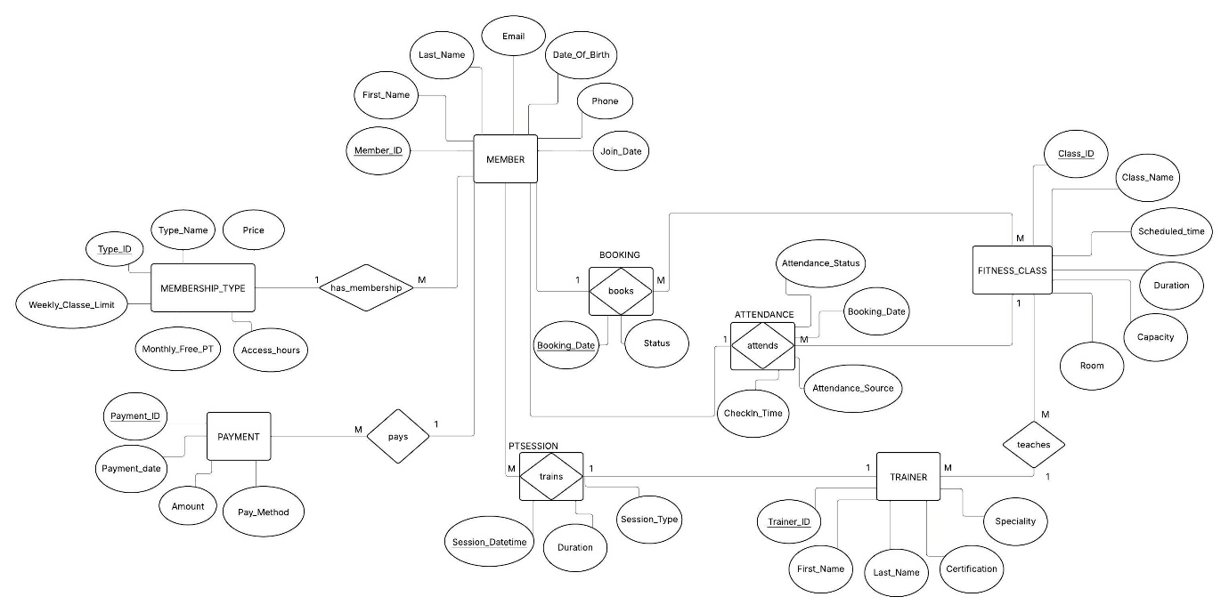
Using Chen’s notation, the ERD illustrates the interactions between Pulse Fitness’s primary entities. Each member (who belongs to a single MembershipType) can make multiple bookings for scheduled fitness classes given by a single trainer, and each booking generates a single attendance record (attended or no-show). Additionally, Premium Members are only allowed to schedule one PT session per month, and each payment is associated with a certain member. The 1-M and M-M cardinalities record the actual booking and attendance processes, the primary and foreign keys enforce these relationships, and the CHECK constraints encode business rules (tier limits, valid statuses).

1.3. Logical Schema & Sample DDL along with Sample Data
MembershipType
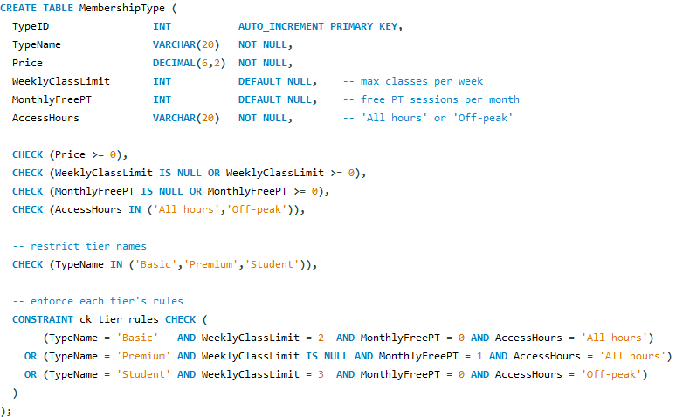
Pulse’s three subscription tiers Basic, Premium, and Student are defined in the MembershipType table, which also encodes the costs, weekly class restrictions, complimentary PT sessions, and access-hour regulations for each tier. This guarantees that use limits and expenses for each member are automatically applied at the database level.
Sample Data
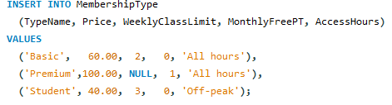

Sample Output
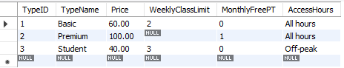

Member
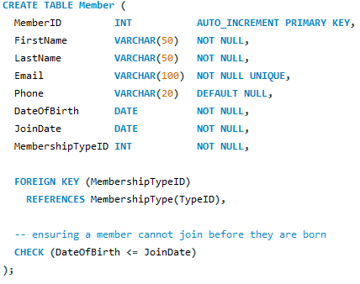
Each Pulse Fitness customer’s personal and account details are stored in the Member database, which also links them to a certain membership tier and ensures that the fields are unique. Additionally, it guarantees that nobody can join before their birthdate.
Sample Data
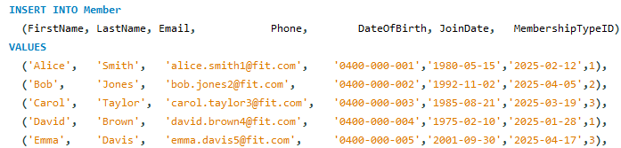
Sample Output
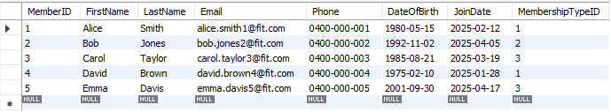
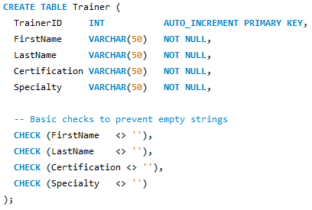
Trainer
The Trainer table contains each personal trainer’s identity, professional certification, and specialized area, ensuring that classes and PT sessions are assigned to adequately competent staff.
Sample Data
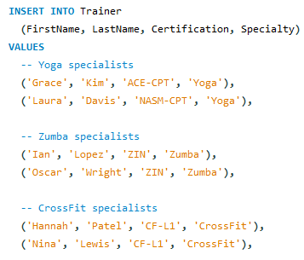

Sample Output
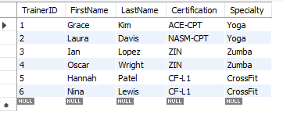
FitnessClass
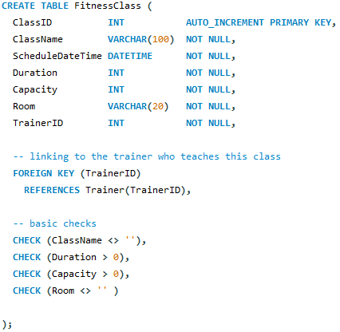
The FitnessClass table records every scheduled group workout, including the name, date/time, room, capacity, and trainer leading it, and serves as the foundation for class booking, utilization, and attendance analysis.
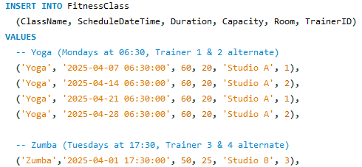
Sample Data

Sample Output
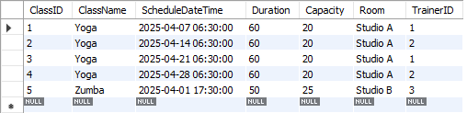
Booking
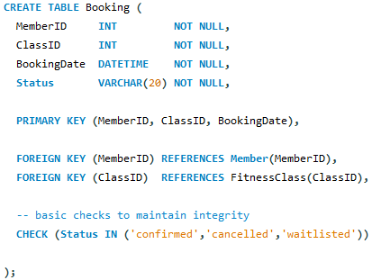
For each planned fitness class session, the Booking database keeps track of each member’s reservation status confirmed, cancelled, or waitlisted. This is necessary to monitor demand, enforce tier restrictions, and provide data for our attendance and utilization evaluations.

Sample Data
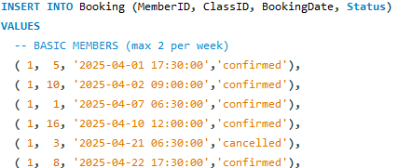
Sample Output
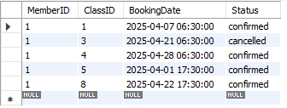
PTSession
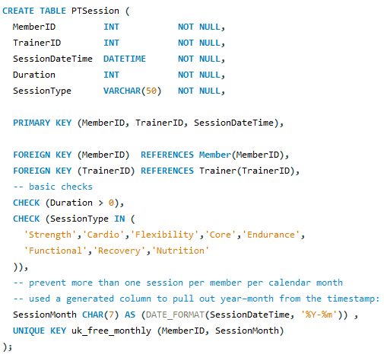
Each premium member’s personal training booking is recorded in the PTSession database, which also keeps track of the trainer and session type selected and enforces the “one free PT session per calendar month” regulation.

Sample Data
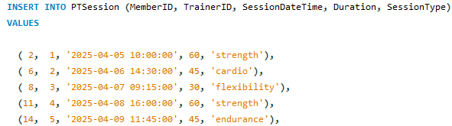

Sample Output
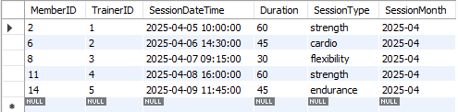

Attendance
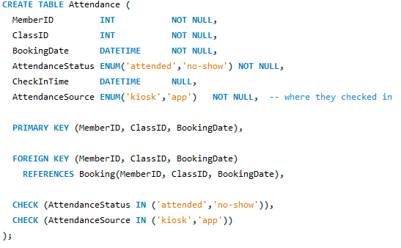
The Attendance table documents whether a confirmed reservation led to a no-show or an actual check-in, as well as the member’s check-in time and method (app or kiosk).
Sample Data
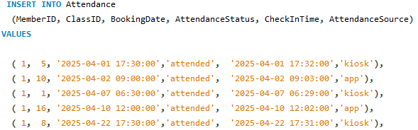
Sample Output
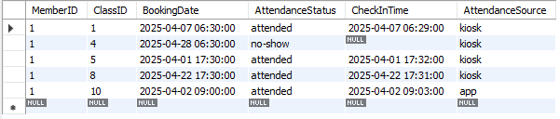

Payment
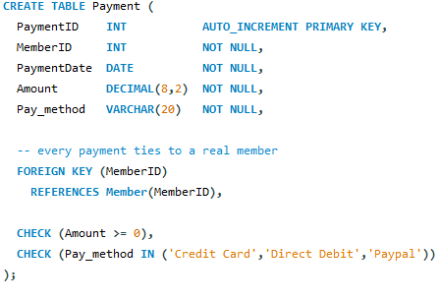
Each member’s monthly dues payment is recorded in the Payment table, along with the amount, date, and method. This guarantees that we can monitor revenue collection, the promptness of payments, and the channels of choice for payments.

Sample Data
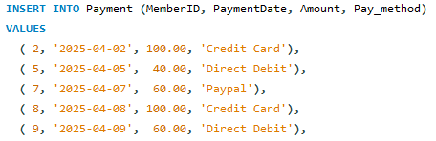
Sample Output
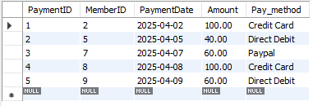

2. Part B: Business Analytics & Insights

2.1. Identified Business Concerns
- Class Utilization & Capacity Management
- Attendance Conversion Rate
- Check-In Channel Effectiveness
- Member Engagement & Retention Risk
- Trainer Workload Balance & Effectiveness
- Booking Frequency Distribution
- Class Variety

2.2. Query Formulation Principles
Every Part B query anchors each statistic in the same timeframe for direct comparison, using a consistent filter to the confirmed records from April 2025. Each analysis uses transparent SQL constructs (COUNT for totals; SUM (CASE WHEN … THEN 1 ELSE 0 END) for conditional counts, and ROUND for ratios) and only joins the tables necessary to its question, such as Booking and Attendance for conversion rates, FitnessClass and Booking for utilization, and Trainer, FitnessClass and Booking for workload etc. To make outputs instantly comprehensible, results are organized according to the dimensions such as class/week, member, trainer, or check-in channel. Additionally, domain-aligned column names, such as UtilizationPercent and AttendanceRatePct, are used. We assured correctness, clarity, and actionability by creating each query step-by-step.

2.3. Analytical Findings & Recommendations
Class Utilization & Capacity Management
Overcrowding results in a bad experience, and empty spots cost money. Monitoring the proportion of confirmed bookings to class capacity by week and class reveals areas for session alterations or removals as well as room size adjustments.
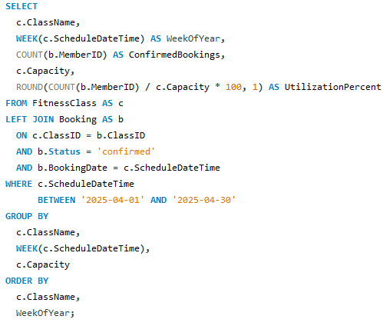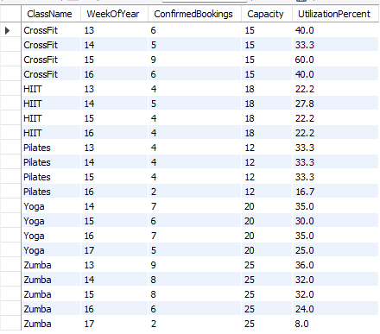
Key insights
- Week 15 sees the highest demand for CrossFit (60% usage), all other weeks fall between 33 and 40%, suggesting that there is one especially well-liked session in the middle of the month.
- HIIT continuously performs well below capacity, ranging from 22 to 28 %, indicating a mismatch between member interest and available slots.
- Pilates initially maintains an occupancy rate of about 33%, but in Week 16, it falls to 17%, possibly as a result of scheduling difficulties or less promotion.
- Yoga attendance is consistent at about 30–35%, but it drops to 25% in the last week, indicating a decline in late-month participation.
- Zumba shows a steep dip by the conclusion of the month, dropping from 36% in Week 13 to just 8% in Week 17.
Reccomendations
- Include a CrossFit session during the busy mid-April period to capitalize on the 60% plus enrolled class.
- Repurpose unused HIIT sessions by combining two low-attendance timeslots and providing complimentary trial tickets to pique interest.
- Before Week 16, offer a promotion like “2-for-1 Friday Pilates” flash sale to get members back on track after a 16.7% capacity decline.
- To increase its 8% utilization, move the Week 17 Zumba class to an earlier afternoon time or provide an introductory incentive (such as a free first class).
- Introduce a cross-class bundle to balance demand and increase fill rates in underbooked sessions .
Attendance Conversion Rate
Monitoring the proportion of confirmed bookings that result in attended sessions reveals areas where no-show rates are costing money and wasting trainer time, as well as engagement gaps.
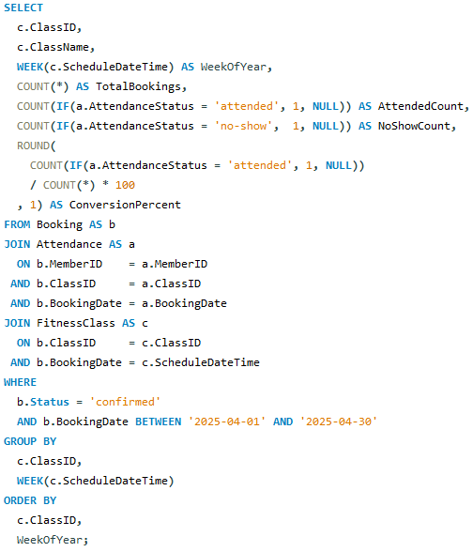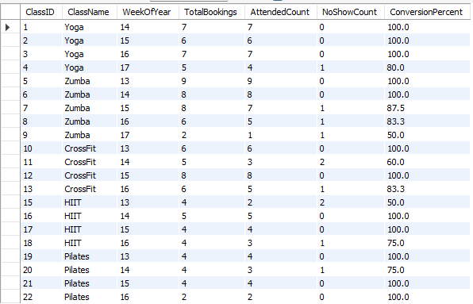
Key Insights
- Yoga maintained a 100% conversion rate from weeks 14–16, but in week 17, it dropped to 80%, indicating possible end-of-month exhaustion.
- Indicating an increase in no-shows, the Zumba conversion rate gradually decreased from 100% (week 13) to just 50% (week 17).
- CrossFit was inconsistent, showing only 60% in week 14 but perfect in weeks 13 and 15, suggesting potential scheduling conflicts.
- As a result of uncertain commitment, HIIT peaked at 100% in week 14 but fell to 50% in week 13 and 75% in week 16.
- With the exception of a 75% decline in week 14, which was noted for evaluation, Pilates held up well.
Reccomendations
- To cut down on no-shows, set up automated 24-hour SMS/email reminders for sessions with a conversion rate below 85% .
- Provide early check-ins for HIIT and Pilates sessions with conversion dips with a modest loyalty credit .
- To deter dropouts, impose a small late cancellation fee on repeat no-shows in low-conversion classes.
- For CrossFit week 14, run a “bring-a-friend” promotion to re-engage members and fill unused spaces.
- Repurpose trainers to more popular sessions and combine or reschedule periods that are consistently underattended, such as week 17 of Zumba.
Check-In Channel Effectivenes
Evaluating attendance by check-in source reveals differences in how members confirm their attendance. A lower app attendance percentage indicates usability or reminder gaps, which result in unwanted no-shows.
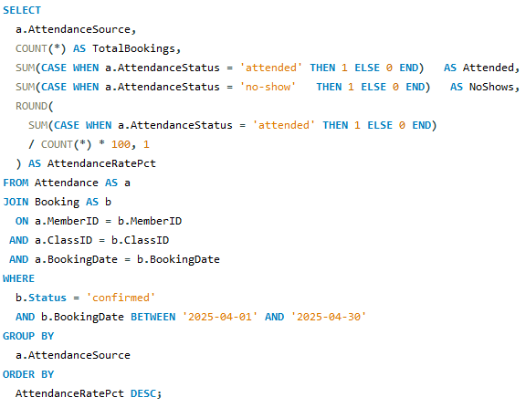
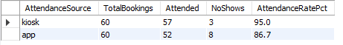
Key Insights
- Kiosks perform better than apps the physical terminal is more successful at recording attendance, with kiosk check-ins converting at 95.0% compared to the app's 86.7%.
- The majority of no-shows are caused by apps: of the 11 no-shows that occurred, 8 (73%) were from the app channel, suggesting a higher drop-off rate following mobile booking.
- Even booking volumes: each channel recorded 60 bookings, indicating that channel experience rather than an imbalance in utilization is the cause of the performance discrepancy.
Reccomendations
- To cut down on missed check-ins, give app users a one-tap push reminder thirty minutes before to class.
- Reduce login friction by streamlining in-app check-in with a persistent “Check-In” widget or QR-code scan.
- Provide a “Confirm Attendance” prompt within the app that automatically releases open seats to those on the queue.
- In order to facilitate mobile check-ins and promote best practices for app uptake, staff designated kiosks during peak hours.
- Track weekly performance of the channel and make adjustments, such as adding more kiosks where app conversion is the lowest.
Member Engagement & Retention Risk
Long gaps since a member’s last booking and low attendance rates are reliable indicators of churn. Before they cancel, management can target re-engagement by alerting people with outdated bookings or poor attendance.
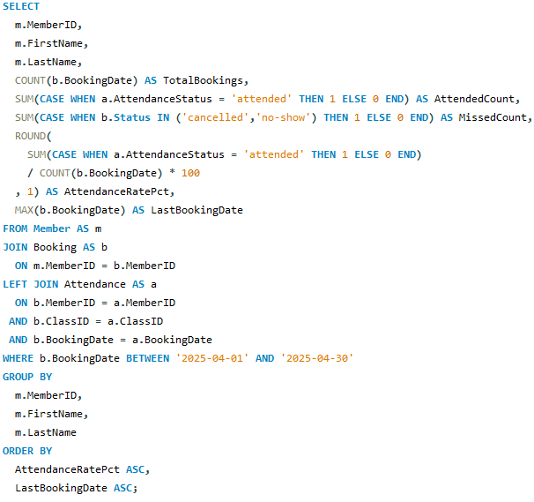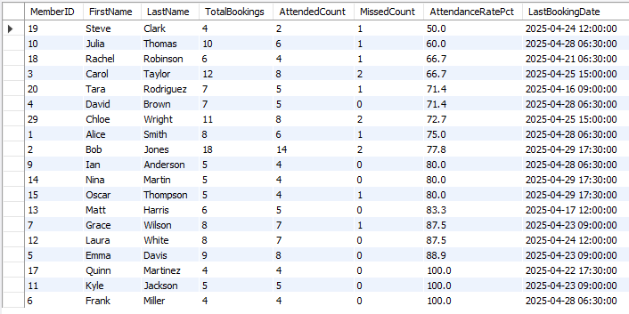
Key Insights
- High-risk members: Four members have attendance below 70%, which indicates an immediate churn risk: Julia Thomas (60%, 04-28), Rachel Robinson & Carol Taylor (approx - 66.7%, 04-21/04-25), and Steve Clark (50% attend, last scheduled 04-24).
- Mid-risk gap: Alice Smith, David Brown, Tara Rodriguez, and Chloe Wright (71–75% attendance) haven't made a reservation in 5–9 days, indicating fading engagement.
- Loyal advocates: Frank Miller, Quinn Martinez, and Kyle Jackson are among the members who attend 100% of meetings; they are effective champions for referral programs.
Reccomendations
- Dynamic Class Matching to increase relevance and booking possibility, send weekly “Recommended Classes” emails that highlight sessions that each member has attended at least 80% of the time.
- Flex-Credit Rollovers feature turns missed reservations into sustained participation by allowing members who miss one class each month to convert that no-show into a “flex credit” that may be used for any non-peak session.
- After-No-Show Quick Response send a one-click survey as soon as possible following a no-show, asking them why they were unable to attend. Staff members will then review the responses and provide individualized rebooking or assistance.
- Gamified Streak Challenges will make attendance an enjoyable and motivational game by implementing a “3-in-7” attendance challenge for at-risk members. They must finish three classes in a week to receive a free smoothie or branded gym merchandise.
Trainer Workload Balance & Effectiveness
Consistent member experience and prevention of burnout are ensured by evenly spaced classes. Monitoring each trainer’s booking load, scheduled sessions, and attendance rates reveals areas that require coaching or assignment rebalancing.
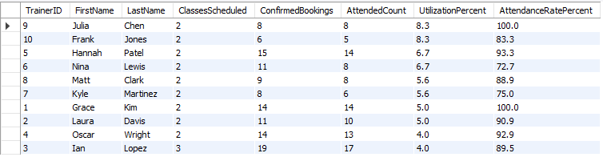
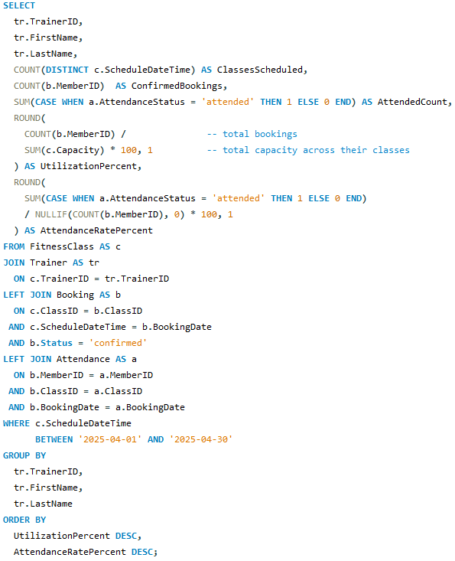
Key insights
- Ian Lopez has the most reservations (19), yet just 4% of his sessions are filled, suggesting that the number of rooms and the demand are not aligned.
- Both Julia Chen and Grace Kim exhibit remarkable member engagement by achieving 100% attendance during their sessions.
- Nina Lewis had the lowest attendance conversion (72.7%), although having a respectable booking volume (11). This suggests that her class schedules or style may not be as enticing.
- Attendance rates for Frank Jones (83.3%) and Kyle Martinez (75.0%) are below the team average, indicating areas with poorer member follow-through.
- The uniformly low overall utilization percentage (less than 10% for all trainers) indicates that many classes are operating well below capacity.
Recommendation
- To increase fill rates and better reflect real turnout, reassign one of Ian Lopez’s high-capacity sessions to a co-instructor or a smaller studio.
- Record the finest practices of Grace Kim and Julia Chen and apply them to all trainer’s methods.
- Test out other times or formats for Nina Lewis’s classes; to pique interest again, consider introducing a promotion like “bring a buddy day” who can take the membership at a lesser cost.
- To maximize space and prevent vacant slots, dynamically adjust room allocations every week depending on utilization data from the previous month.
Booking Frequency Distribution
Understanding how frequently members book sessions identifies both super-users who drive usage and low-engagement members who are at risk of leaving.
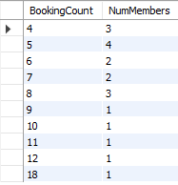
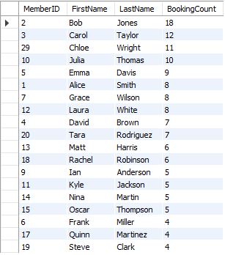
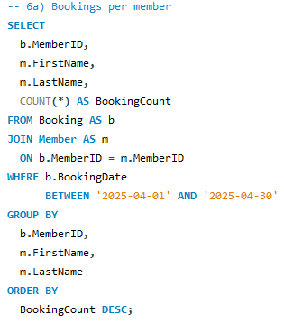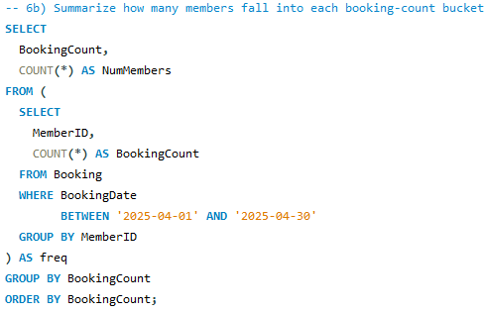

Key Insights
- A strong mid-tier engagement cohort is demonstrated by the usual booking count of 5 sessions (22% of members).
- Only four bookings were made by a sizable group (17%), indicating a risk category with slightly below-average activity.
- An “up-and-coming” category that is primed for upselling is represented by the 11% of customers who made 6–7 bookings.
- Disproportional usage is caused by the 6% of members who are super-users, making 10 plus reservations.
Recommendations
- Auto-Subscribe permit participants to sign up for a “Weekly Class Subscription” for a single time slot of their choice. Automating those reservations reduces conflict, particularly for individuals who make four or six reservations, and ensures that habits are formed.
- Micro-Bundle deals offer a 10% discount on a limited-time “5-Class Power Pack” to anyone with five or seven reservations in April. You may turn infrequent users into regular attendees without overwhelming them by putting together tiny packs.
- Active communication with members has a member of the front desk staff make a brief check-in call after identifying the 3–4 booking group. By asking about their experience and encouraging them to attend future classes, you can convert marginal bookers into regulars.
- Loyalty milestones in Tiers create an in-app “Booking Milestone” badge where users can gain “Silver Member” benefits by making eight bookings in a month. Members who are lingering below the next tier are encouraged to push past their typical level by gamifying frequency.
Class Variety
In addition to increasing member satisfaction and engagement, encouraging members to try out different class types also more evenly distributes demand among programs, which raises overall utilization and revenue.
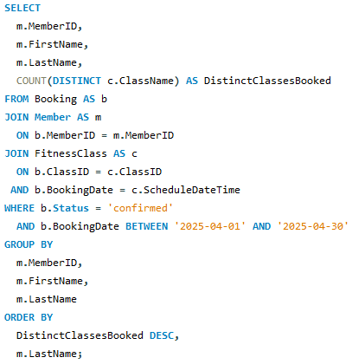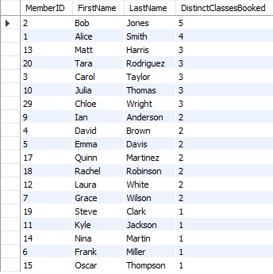
Key Insights
- Limited participation of members 7 out of 15 participants (about 47%) only attended one or two class kinds, suggesting that many are sticking to just one favourite
- Explorer cohort is a tiny subset of members (such as Alice Smith with four types and Bob Jones with five) is propelling increased visitation and wider acceptance.
- Members who book three or more different classes also rate highly in terms of overall bookings, highlighting the importance of diversity in fostering loyalty.
- Compared to Premium, student-tier members typically take fewer different classes, which may indicate that off-peak hours discourage exploration.
Recommendations
- Class Passport Program: Introduce a digital “passport” that offers incentives to participants who try out different class kinds. Benefits are unlocked at 3, 5, and 7 distinct sessions.
- “Try New Class” in-app Ideas for prompts and providing single-type bookers with customized push messages that suggest underutilized classes, such as “You loved yoga! have you tried Pilates?”
- Instructor Cross-Promos can be used to raise awareness of complimentary formats, provide instructors with a brief “next class suggestion” script to read at the conclusion of a session.
- Monthly Variety Blitz: To encourage the testing of less-attended sessions, hold themed fusion weeks such as “Cardio and Core Fusion” with bundled price.

Conclusion
In this assignment, we provided a comprehensive, end-to-end solution for Pulse Fitness that combines rigorous database design with practical analytics. In Part A, we used a Chen ER diagram and a normalized relational schema to represent the gym's processes, including members, tiers, trainers, classes, bookings, PT sessions, attendance, and payment. Key business rules (tier limitations, one free PT each month, age vs. join-date, and capacity checks) were implemented directly in the SQL DDL using primary/foreign keys and check constraints. To replicate actual operational conditions, we loaded each table with realistic April 2025 sample data.
Part B expanded on this basis by addressing seven business concerns, including class utilization, attendance conversion, check-in channel effectiveness, member engagement risk, trainer workload balance, booking frequency distribution, and class variety. For each, we created simple SQL queries that join only the required tabless, use transparent conditional aggregates, and group by the dimensions that managers care about. The resulting insights such as underutilized time slots, classes with increased no-show rates, and at-risk member segments were combined with specific, business-driven recommendations to optimize scheduling, increase engagement, rebalance resources, and adapt messages.
These deliverables provide Pulse Fitness with both the data infrastructure and the analytical playbook to operate more efficiently and proactively. By embedding business logic into the database layer and establishing a clear, repeatable query methodology, the company can maintain performance monitoring, respond quickly to emerging patterns, and increase member satisfaction and revenue development. This research highlights how a well-designed database, along with targeted analytics, can be a strong engine for making informed decisions in a dynamic fitness setting.

